|  |
| --- |
| **Spell Chant Typer** |
| **A Web Programming Project by** |
| **Kristian Ragonton** |
| **Submitted to the Undergraduate Programs**  **Ateneo De Davao University** |
| **In Partial Fulfilment**  **of the Requirements for the degree**  **Bachelor of Science in Computer Science** |
| **March 2023** |

ACKNOWLEDGMENTS

I would fully, from the very bottom of my heart, thank my big sister Kel Ragonton for her major contribution towards the GUI and CSS design of the game aswell as various advice and ideas that contributed into the game itself.

TABLE OF CONTENTS

APPROVAL SHEET 2

ACKNOWLEDGMENTS 3

TABLE OF CONTENTS 4

LIST OF TABLES 6

LIST OF FIGURES 7

INTRODUCTION 8

1 THE PROJECTION DESCRIPTION 1

1.1 Problem Encountered 1

1.2 Objective of the Project 1

1.3 Limitation of the Project 1

2 PROJECT MODULES 2

2.1 Administrator 2

2.2 Users 2

2.3 Feature 1 2

3 THE INPUT OUTPUT OF THE PROJECT 3

3.1 The Input of the Project 3

3.2 The Output of the Project 3

3.3 Competitive Advantage 3

3.4 Development 3

3.5 Specifications 3

3.6 Validation 3

4 ANALYSIS 4

4.1 Process Logic 4

4.2 Data Flow Diagram 4

5 Conclusion 5

5.1 Conclusion 5

5.2 Recommendations 5

REFERENCES 6

APPENDICES 7

1. <Appendix A:><Title> 7

LIST OF TABLES

LIST OF FIGURES

Figure 1 20

Figure 2 21

Figure 3 21

Figure 4 22

Figure 5 22

Figure 6 23

Figure 7 23

Figure 8 24

Figure 9 24

Figure 10 25

Figure 11 25

Figure 12 26

Figure 13 26

Figure 14 27

Figure 15 27

Figure 16 28

INTRODUCTION

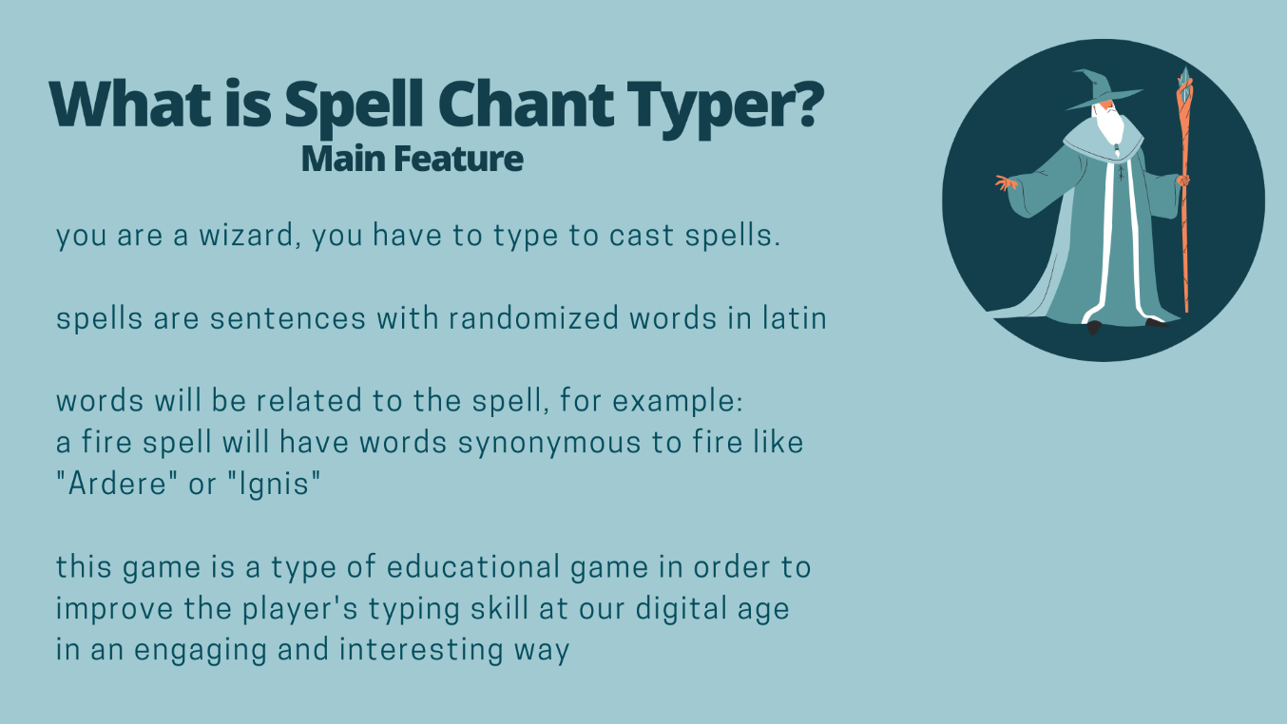

# THE PROJECT DESCRIPTION

## Problem Encountered

There aren't many ways to practice typing in a fun way.

The market is mostly just analytical typing tests that focus on words per minute, and having a low wpm or being compared to average may be discouraging.

The market is also either targeted for children or very old and retro.

## Objective of the Project

Make the user type as often as possible as part of the mechanics.

Have game mechanics that are complex and engaging at the same time.

## Limitation of the Project

The project is specified to mainly use HTML,CSS, and Javascript hence I cannot use some creator tools such as RPG Maker as it displays a different kind of skillset and not what I learned in this course. Due to differences in browser systems regarding local storage, the project should be run on google chrome.

# PROJECT MODULES

## Entrance Page

The starting point of the game, with basic instructions on how to navigate the game.

Has a text input box with an enter button that also triggers upon pressing enter on the keyboard, the input will then be processed for valid values to trigger corresponding functions and to alert the player in the case of invalid values.

In this case the only valid input is “Play” which redirects the player to the Main Hub.

This will also serve as the point where the database values will be initiated.

## Main Hub Page

The link between the Profile, Shop, and Level Picker. This page will serve as a redirect point between those 3 pages, wherein those pages will redirect to this page and the main hub will redirect to those pages. The redundancy of having this page instead of redirecting directly between those 3 pages is for more typing practice.

Has a text input box with an enter button that also triggers upon pressing enter on the keyboard, the input will then be processed for valid values to trigger corresponding functions and to alert the player in the case of invalid values.

Input “Profile” will redirect to the Profile page.

Input “Shop” will redirect to the Shop page.

Input “Embark” will redirect to the Level Picker page.

## Profile Page

This is where the list of spells in the Spell Tome will be displayed, the list of learned spells that are not in the Spell Tome will be displayed, and the spells in the Spell Tome can be modified. Also displays the number of Spell Tome Pages you own which indicates how many spells are allowed in the Spell Tome and the maximum HP or health points the player has which will be relevant in combat. You may also change your name.

Has a text input box with an enter button that also triggers upon pressing enter on the keyboard, the input will then be processed for valid values to trigger corresponding functions and to alert the player in the case of invalid values.

Input “Return” will redirect to Main Hub page.

Input “Inscribe (Spell Name)” will set the spell to be in the Spell Tome and useable for combat. Valid values for (Spell Name) are displayed in the list of spells not in the Spell Tome. The total number of spells in the Spell Tome cannot exceed the number of Spell Tome Pages you own.

Input “Erase (Spell Name)” will set the spell to not be in the Spell Tome. Valid values for (Spell Name) are displayed in the list of spells in the Spell Tome.

## Shop Page

This is where the list of spells that are not learned are displayed with their price, and can be purchased to be learned. This is also where the player can purchase more Spell Tome Pages to increase the maximum number of spells useable in combat and the player can purchase Life Fruit to increase their maximum HP. The player’s gold is displayed, when something is purchased this gold is deducted by the price however the transaction is invalid if the player’s gold is less than the price.

Has a text input box with an enter button that also triggers upon pressing enter on the keyboard, the input will then be processed for valid values to trigger corresponding functions and to alert the player in the case of invalid values.

Input “Return” will redirect to Main Hub page.

Input “Buy (Spell Name)” will set the spell as learned. Valid values for (Spell Name) are displayed in the page.

Input “Buy Spelltome Page” will increase Spell Tome Pages. The price is directly proportional to the number of owned pages. Currently the player can only have a maximum of 5 pages.

Input “Buy Life Fruit” will increase the player’s maximum HP.

## Level Picker Page

This is where a combat encounter level is chosen. The enemy encountered is based on the inputted level. In some levels the enemy encountered is randomized.

Has a text input box with an enter button that also triggers upon pressing enter on the keyboard, the input will then be processed for valid values to trigger corresponding functions and to alert the player in the case of invalid values.

Input “Return” will redirect to Main Hub page.

Input “Go to Practice” will redirect to Combat Encounter Page without setting an enemy leading you to combat with the Target Dummy by default.

Input “Go to Inner Forest” will set the enemy chosen at random, the player will then be redirect to Combat Encounter Page

Input “Go to Outer Forest” will set the enemy chosen at random, the player will then be redirect to Combat Encounter Page

Input “Go to Den of the Forest King” will set the enemy chosen, the player will then be redirect to Combat Encounter Page

## Combat Encounter Page

This is where the player will input sentences to cast spells in combat, and the list of spell in Spell Tome will be displayed with the corresponding randomized sentence. The player’s current and maximum health are also displayed.

The enemy’s name, current health, maximum health, resistances, and the time it takes for the enemy to act will be displayed. In combat the timer will tick every second, when it reaches zero the enemy will act and the timer is reset.

Combat is ended when either the player or the enemy reaches 0 HP and will reward the player with gold for the latter.

Has a text input box with an enter button that also triggers upon pressing enter on the keyboard, the input will then be processed for valid values to trigger corresponding functions and to alert the player in the case of invalid values.

Input “Begin Combat” to start the combat encounter.

Input “Return” will redirect to Main Hub page if you are not in combat.

Input “Retreat” will redirect to Main Hub page if you are in combat.

In combat inputting a sentence matching a saved randomized sentence will activate the spell effect functions for each effect that matches the spell. The sentence will then be randomized again.

# THE INPUT OUTPUT OF THE PROJECT

## The Input of the Project

**Navigation Inputs:**

**Entrance Page:** input “Play”

**Main Hub Page:** input “Profile”

**Main Hub Page:** input “Shop”

**Main Hub Page:** input “Embark”

**Profile Page, Shop Page, Level Picker Page:** input “Return”

**Combat Encounter Page:** input “Return”, only useable when not in combat.

**Combat Encounter Page:** input “Retreat”, only useable when in combat.

**Profile Page Inputs:**

**Inscribe:** input “Inscribe (Spell Name)”,

valid (Spell Name) values displayed in the Learned Spells not in Tome list

**Erase:** input “Erase (Spell Name)

valid (Spell Name) values displayed in the Spells in Tome list

**Shop Page Inputs:**

**Buy Spell:** input “Buy (Spell Name)”,

valid (Spell Name) values displayed in the shop page

**Buy Maximum HP:** input “Buy Life Fruit”

**Buy Page:** input “Buy Spelltome Page”

**Level Picker Page Inputs:**

**Target Dummy Encounter:** input “Go to Practice

**Beginner Encounters:** input “Go to Forest of Beginnings

**Combat Encounter Page Inputs:**

**Combat Start:** input “Begin Combat”

**Spell Casting:** input the specified sentence of a spell

## The Output of the Project

**Navigation Outputs:**

**Entrance Page:** input “Play”: redirect to Main Hub page

**Main Hub Page:** input “Profile”: redirect to Profile page

**Main Hub Page:** input “Shop”: redirect to Shop page

**Main Hub Page:** input “Embark”: redirect to Level Picker page

**Profile Page, Shop Page, Level Picker Page:** input “Return”: redirect to Main Hub page

**Combat Encounter Page:** input “Return”: redirect to Main Hub page

**Combat Encounter Page:** input “Retreat”: redirect to Main Hub page

**Profile Page Outputs:**

**Inscribe:** set spell to be in the Spell Tome,

The spell is displayed in the spell tome list instead of the learned list.

**Erase:** set spell to not be in the Spell Tome,

The spell is displayed in the learned list instead of the spell tome list.

**Shop Page Outputs:**

**Buy Spell:** set spell as learned.

The spell is removed from the displayed spells in the shop page.

**Buy Maximum HP:** increases maximum HP,

Maximum HP is displayed

**Buy Page:** increases number of Spell Tome Pages,

Number of Pages is displayed

**Level Picker Page Outputs:**

**Target Dummy Encounter:** redirect to Combat Encounter page,

Enemy is set to Target Dummy by default

**Beginner Encounters:** redirect to Combat Encounter page,

Enemy is set to Green Slime or Horned Rabbit

**Combat Encounter Page Inputs:**

**Combat Start:** action timer will tick and reset when it reaches 0

**Spell Casting:** spell effects will be triggered

## Competitive Advantage

In comparison to most of the competing games observed:

The project has more complex mechanics

The project does not compare the player with others/ focus on statistical analysis

## Development

**General Input and Navigation**

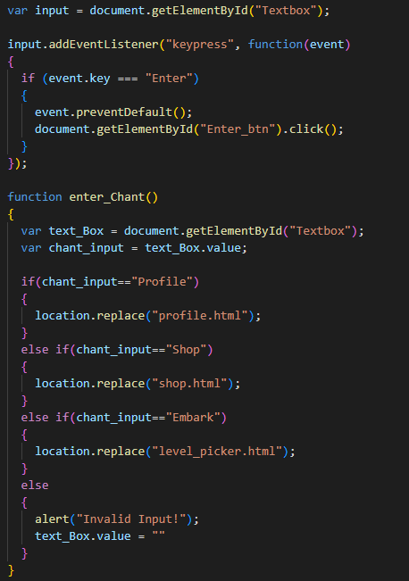

**Entrance Page: Initialization**

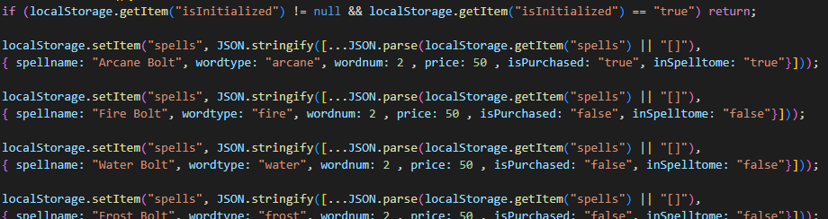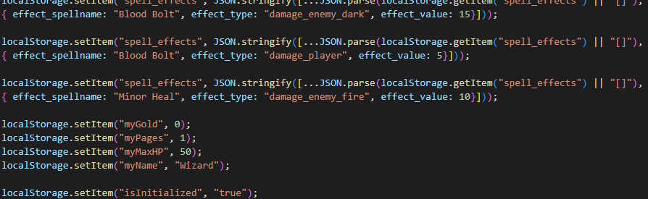

**Profile Page: Loading of Values**

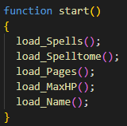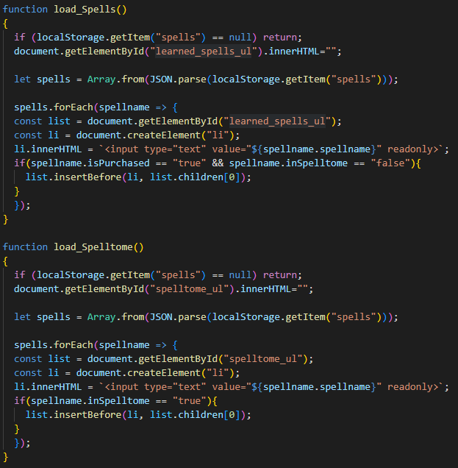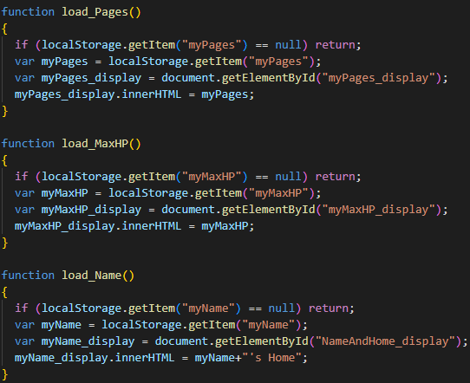

**Profile: Set Name**

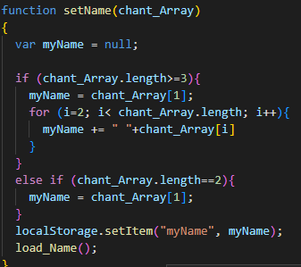

**Profile: Inscribe Spell**

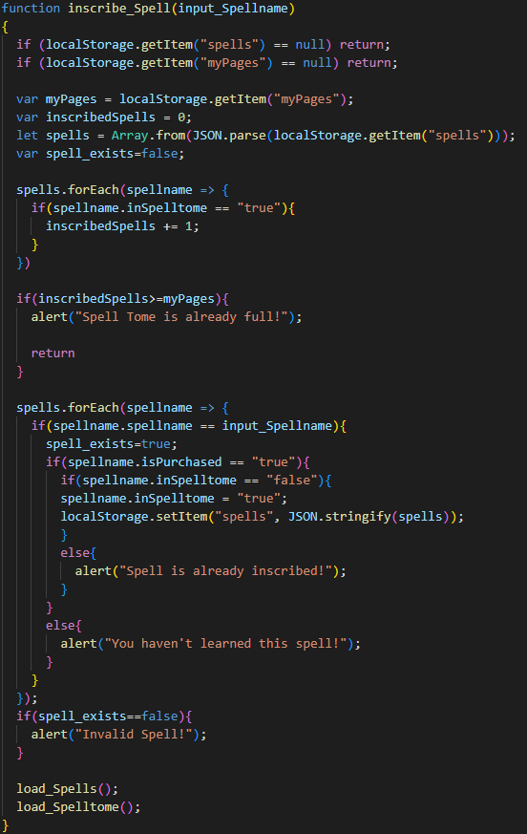

**Profile: Erase**

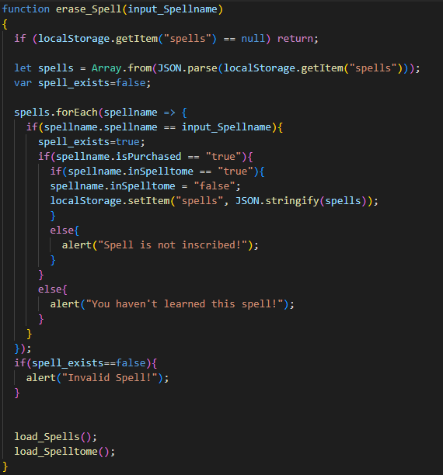

**Shop: Load**

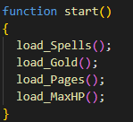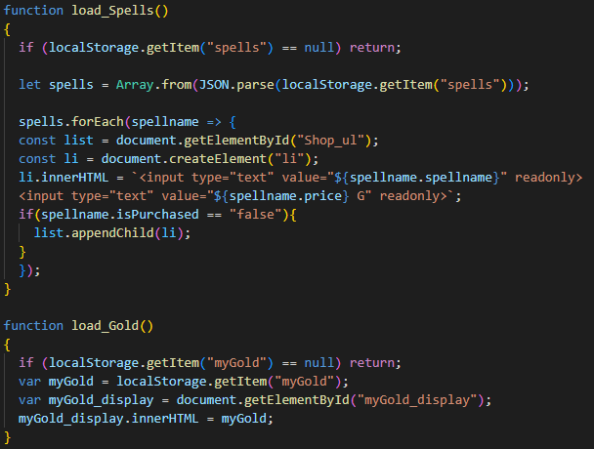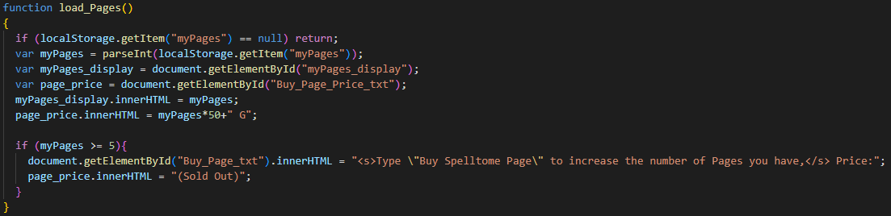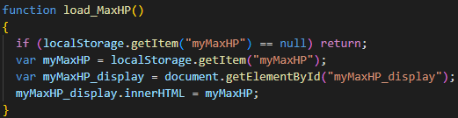

**Shop: Buy Spell**

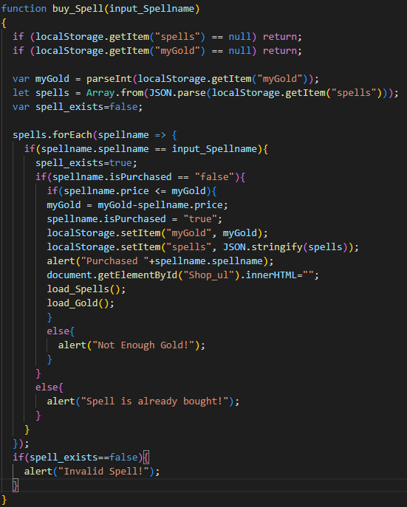

**Shop: Buy Page**

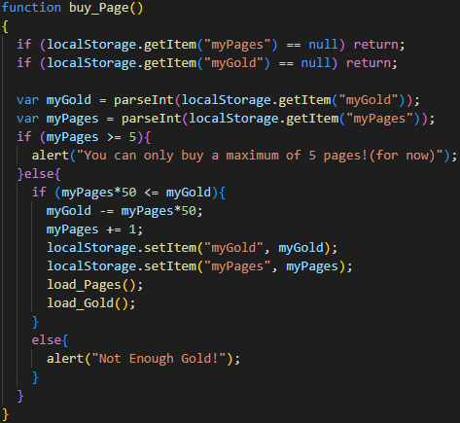

**Shop: Buy HP**

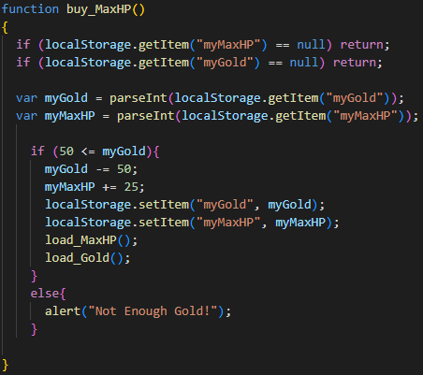

**Level Picker: Load**

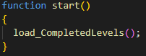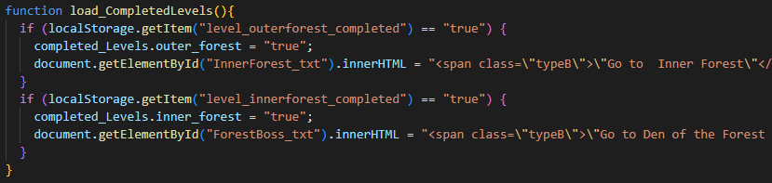

**Level Picker: Set Encounter**

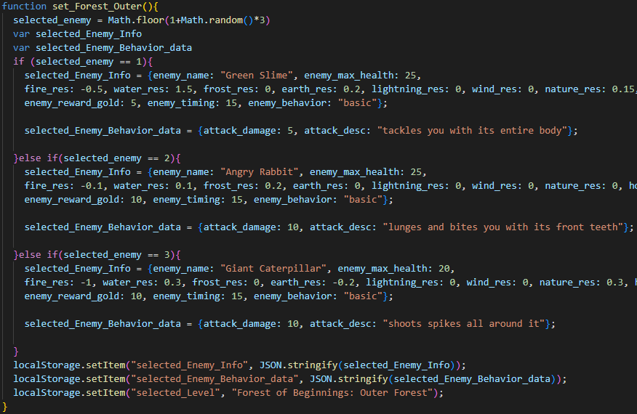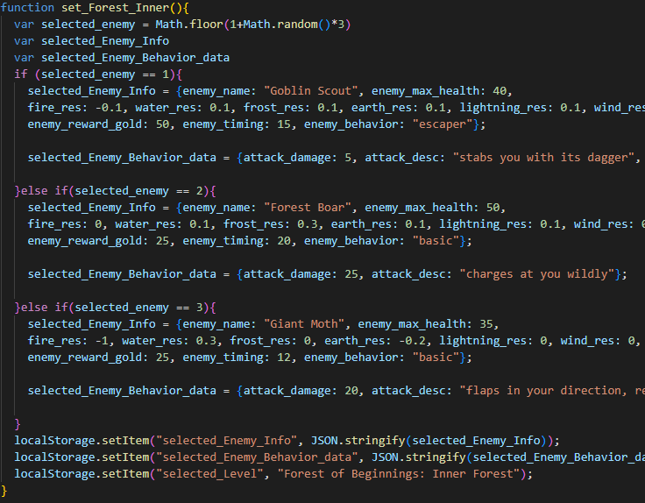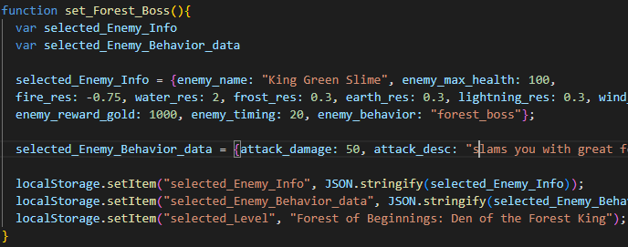

**Combat Encounter: Load**

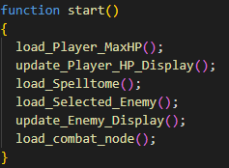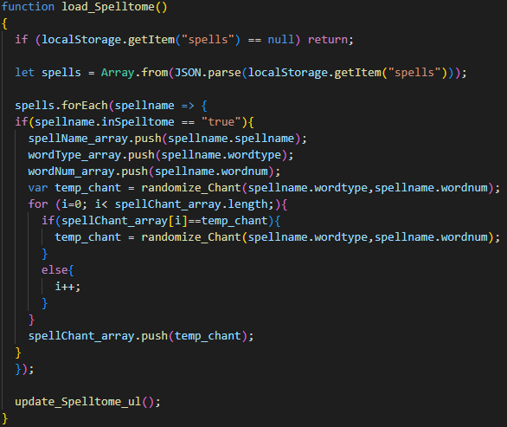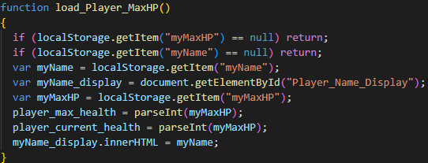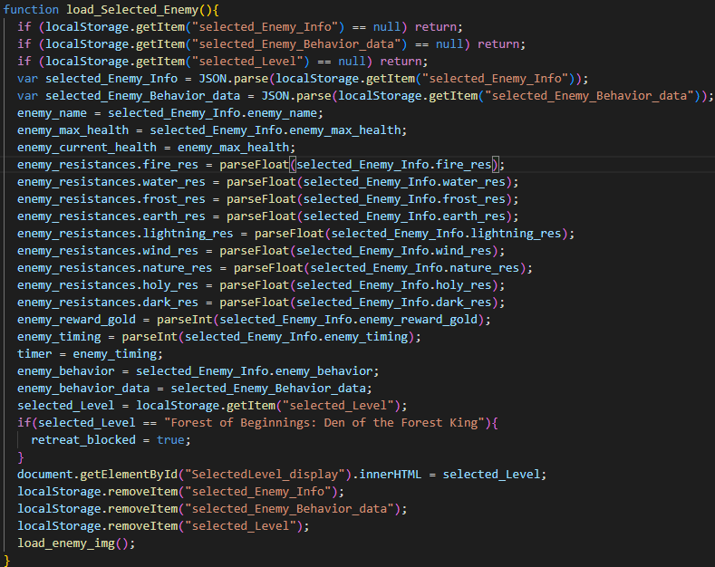

Display functions omitted

**Combat Encounter: Spell Activation**

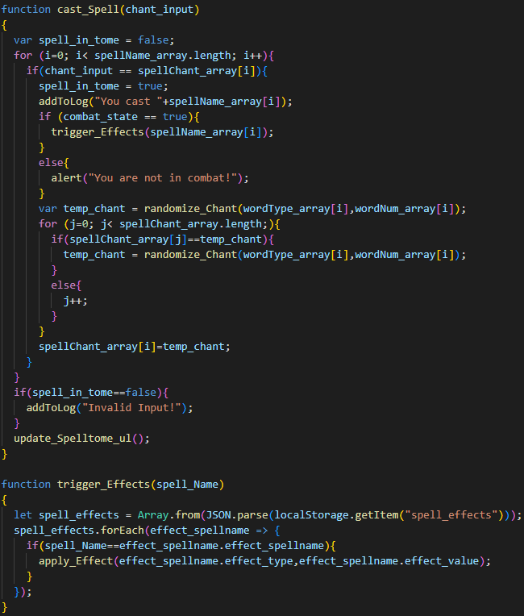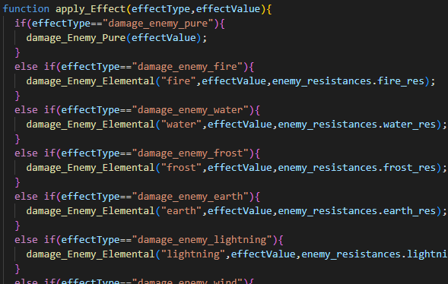

Entire else-if chain omitted,

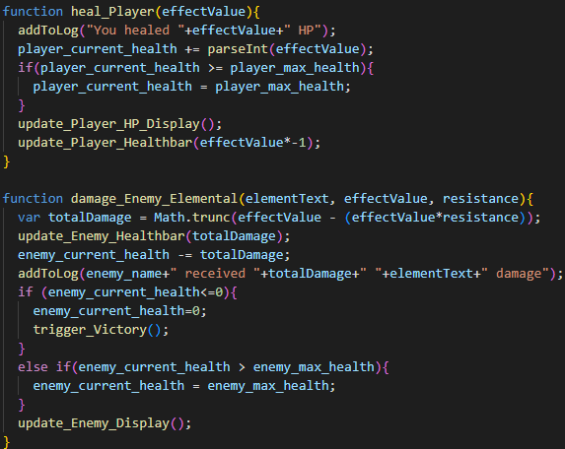

Other effect functions omitted

**Combat Encounter: Enemy Actions**

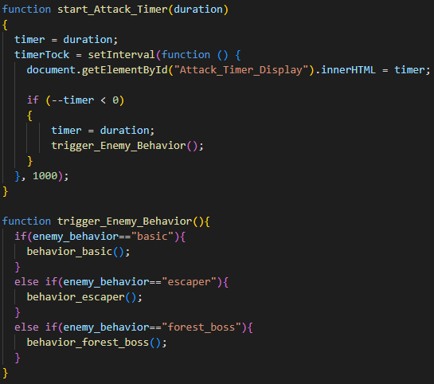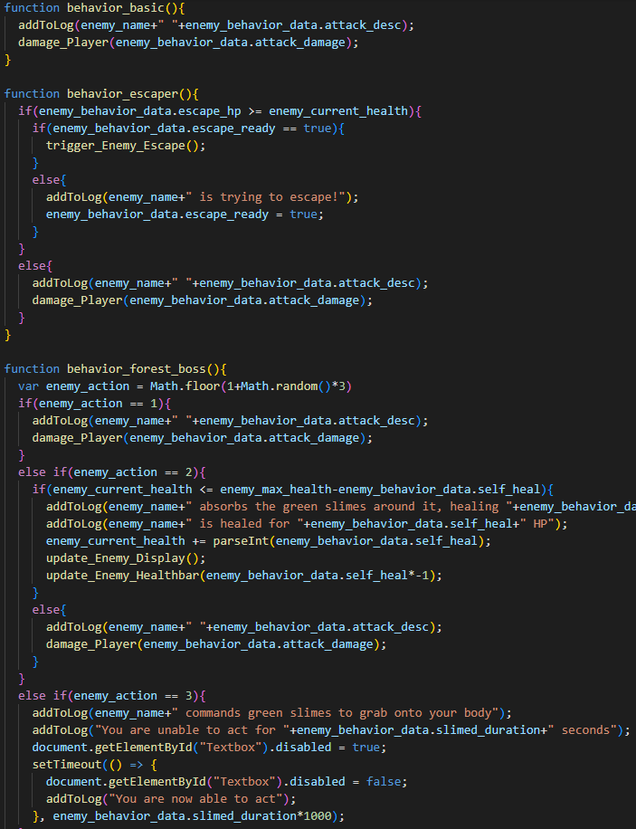

**Combat Encounter: End of Combat**

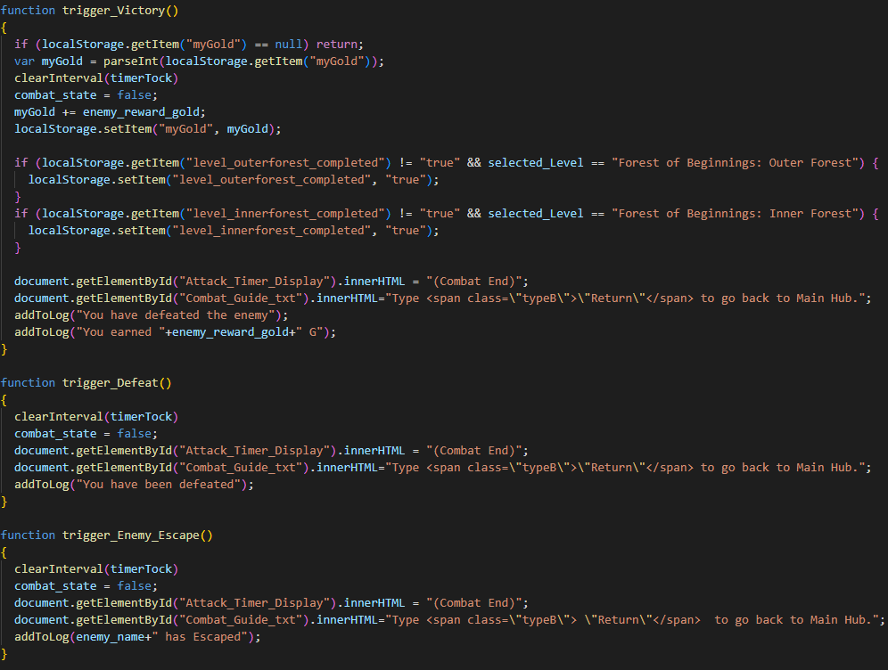

## Specifications

A PC setup with a Monitor, and Keyboard.

Highly Recommended Google Chrome Browser.

## Validation

**General Input Validation**



**Spell Name Validation**

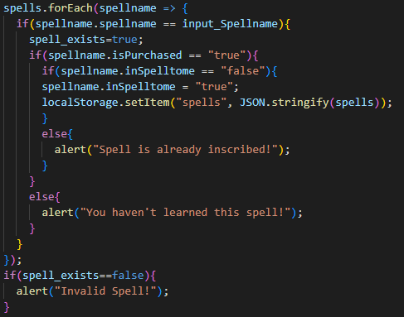

# ANALYSIS

## Process Logic

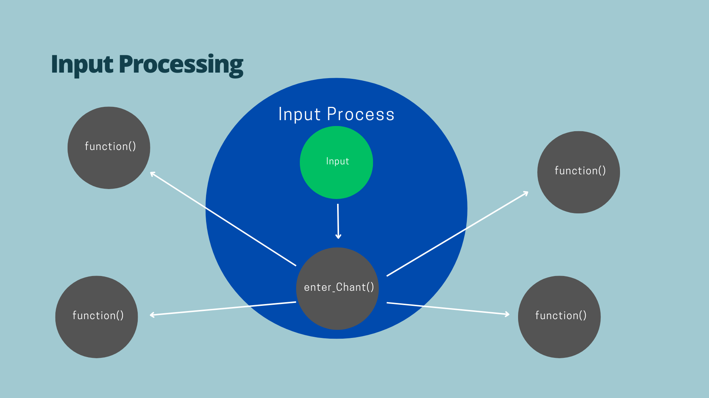

Figure 1

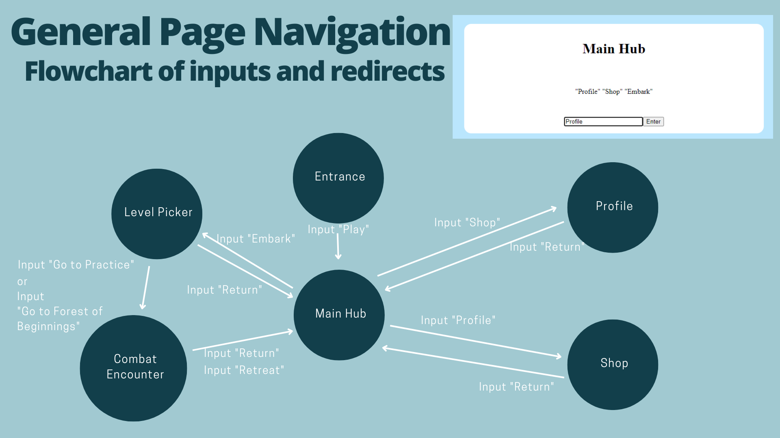

Figure 2

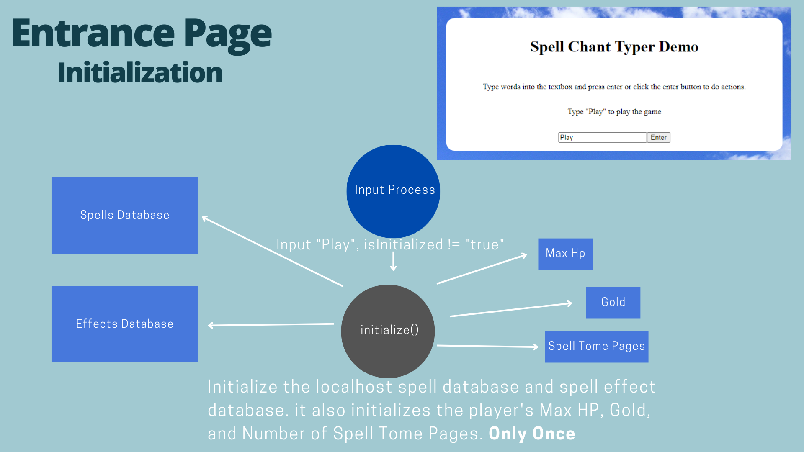

Figure 3

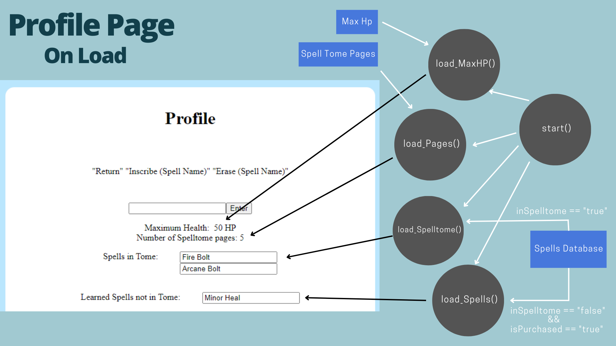

Figure 4

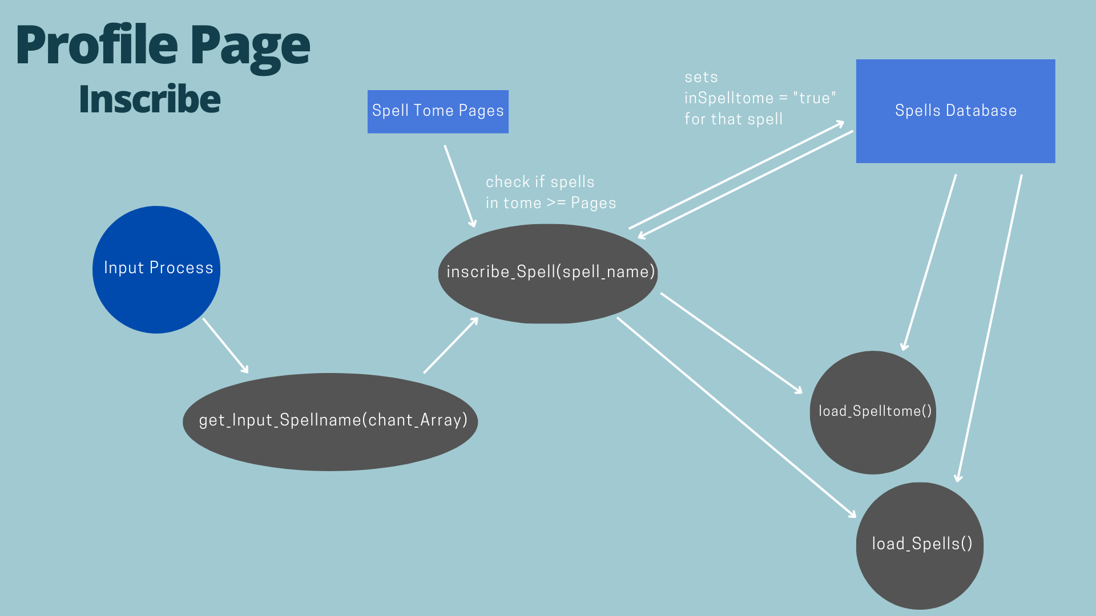

Figure 5

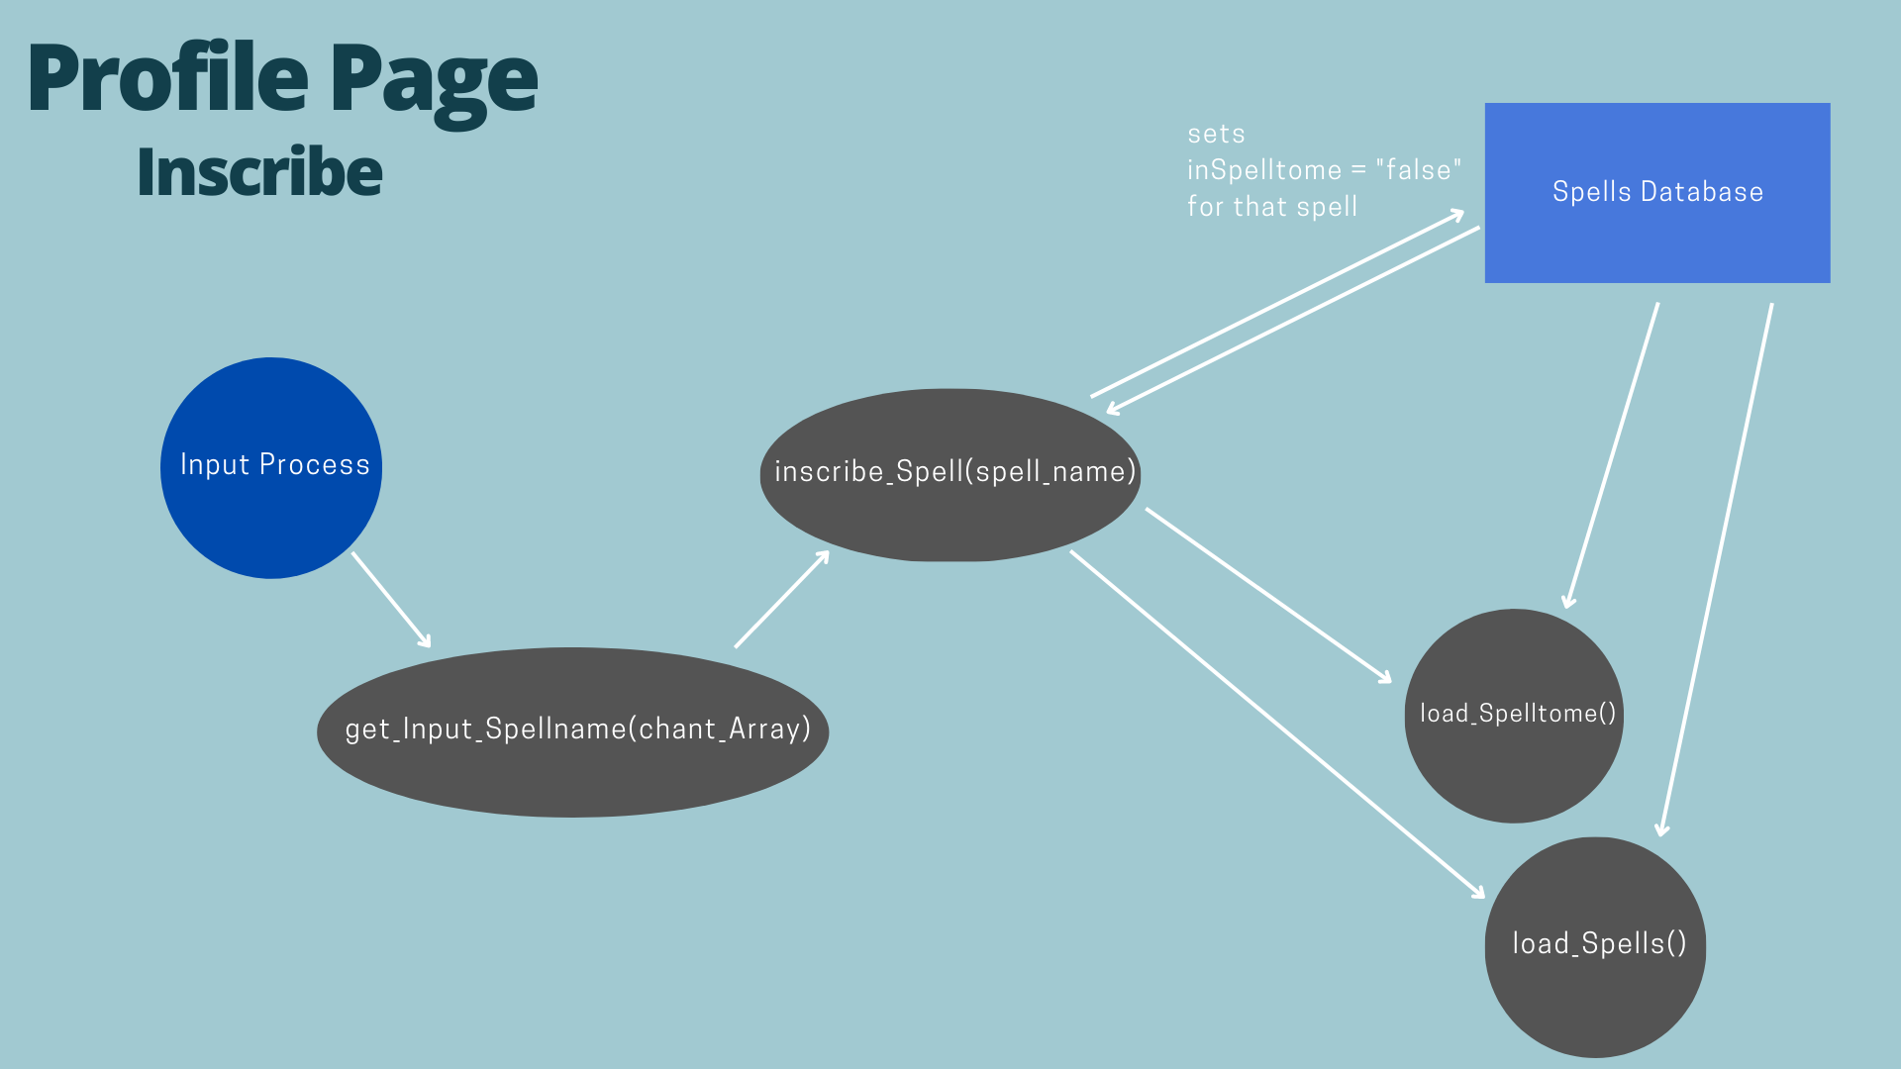

Figure 6

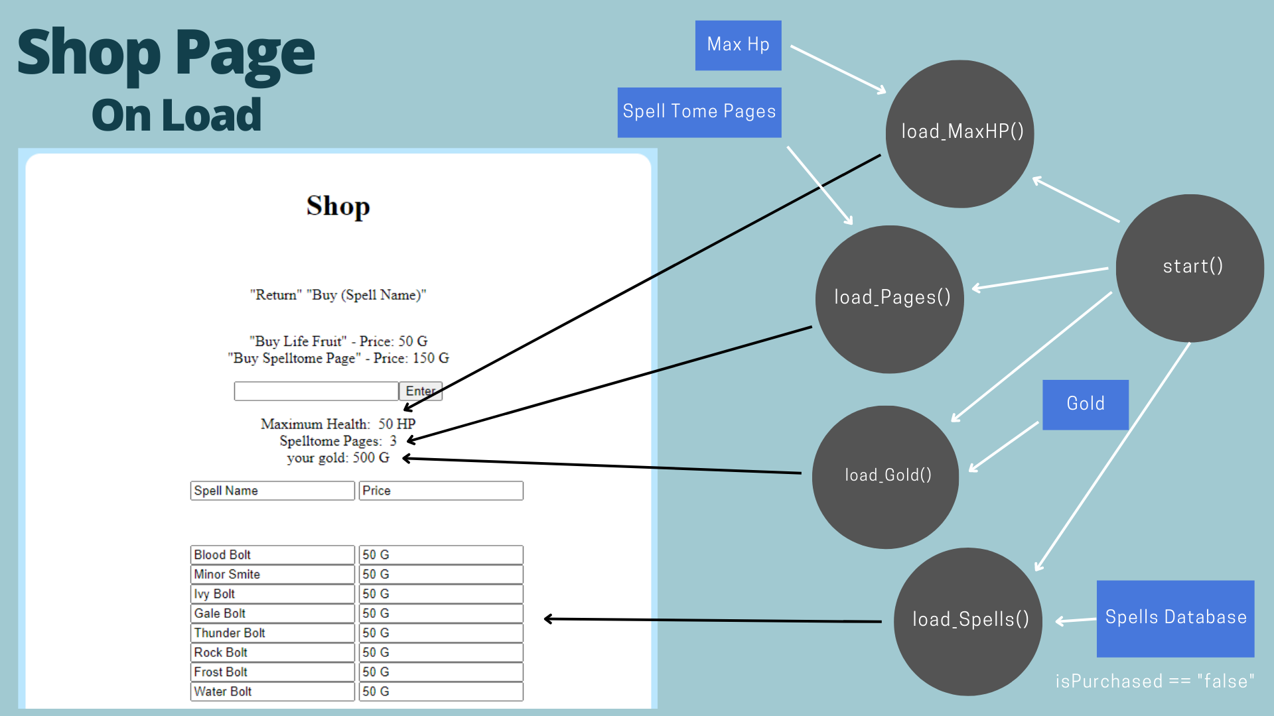

Figure 7

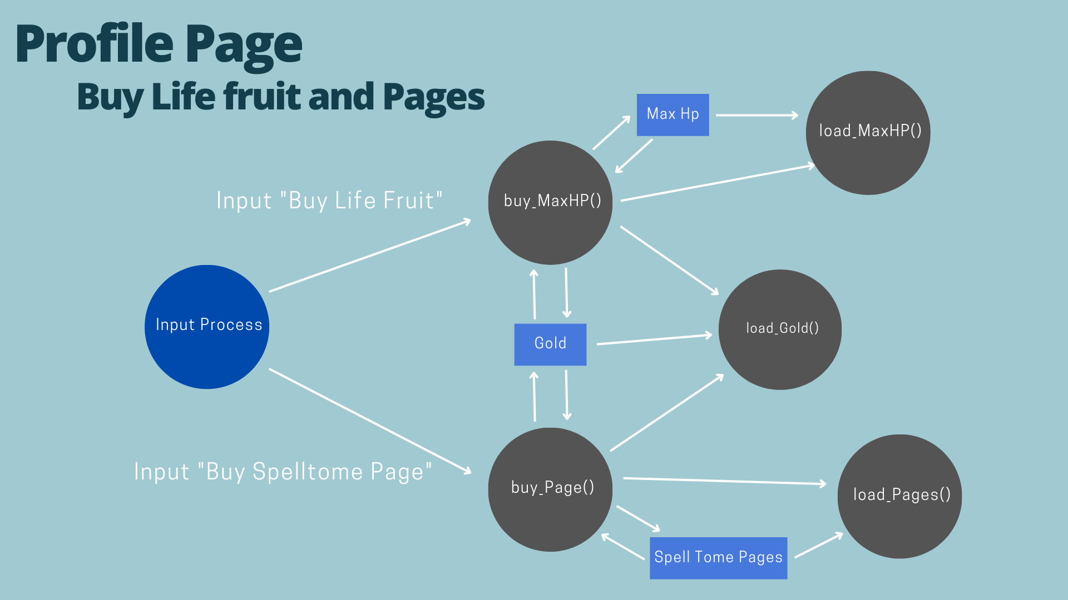

Figure 8

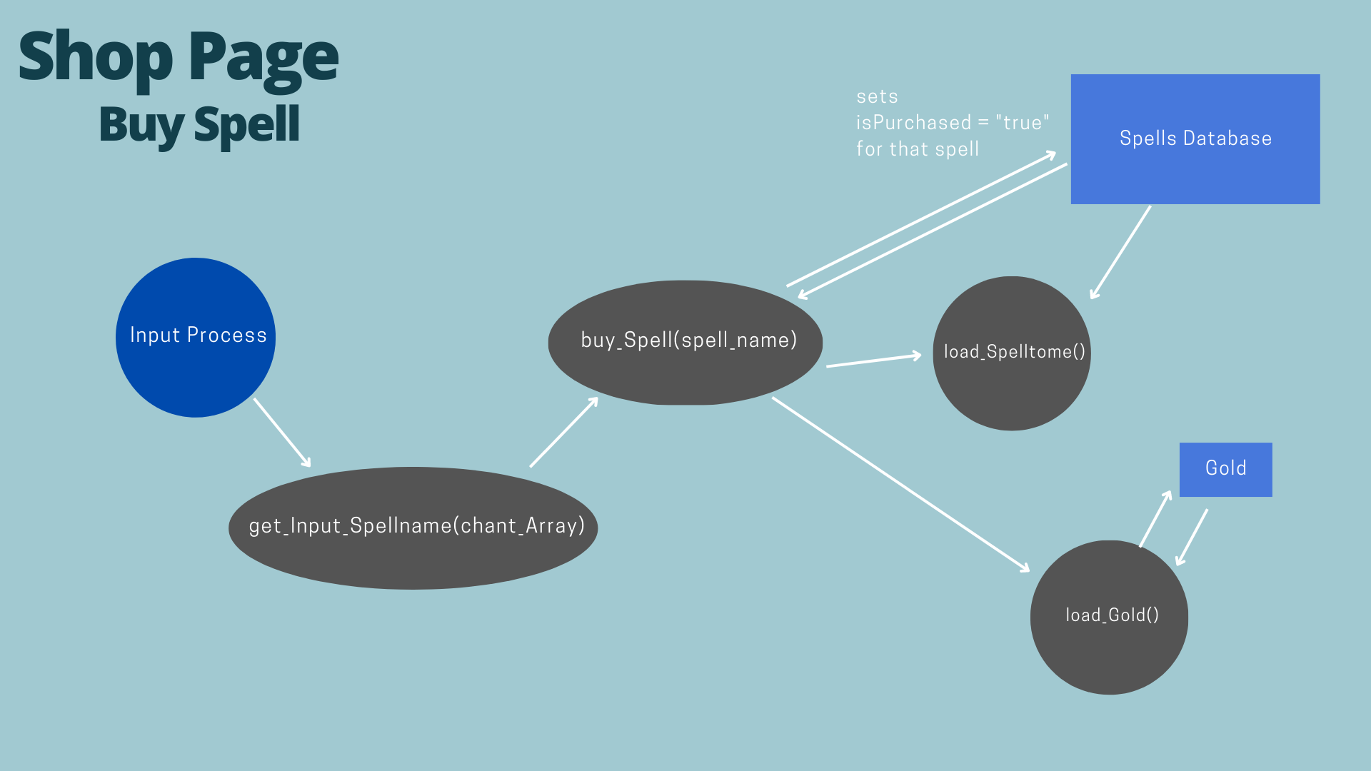

Figure 9

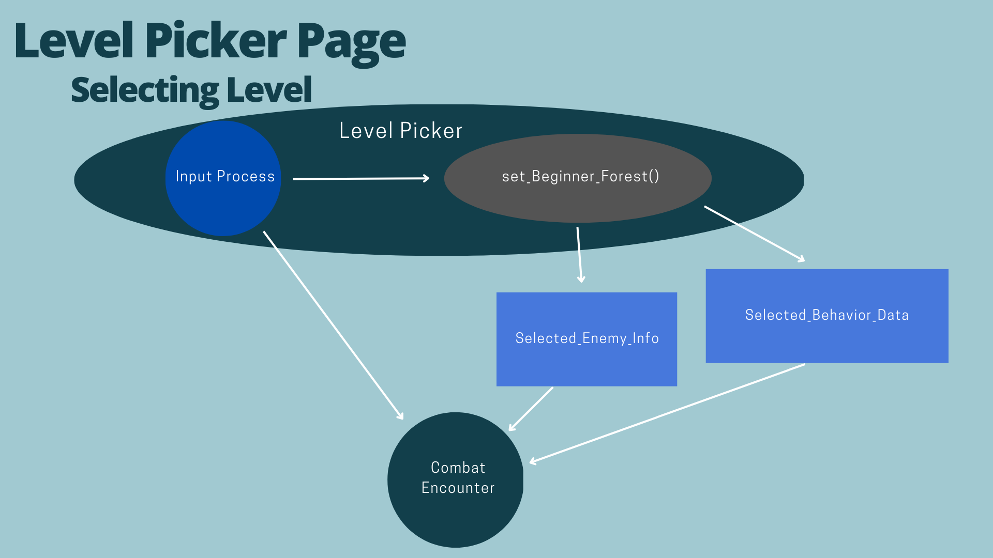

Figure 10

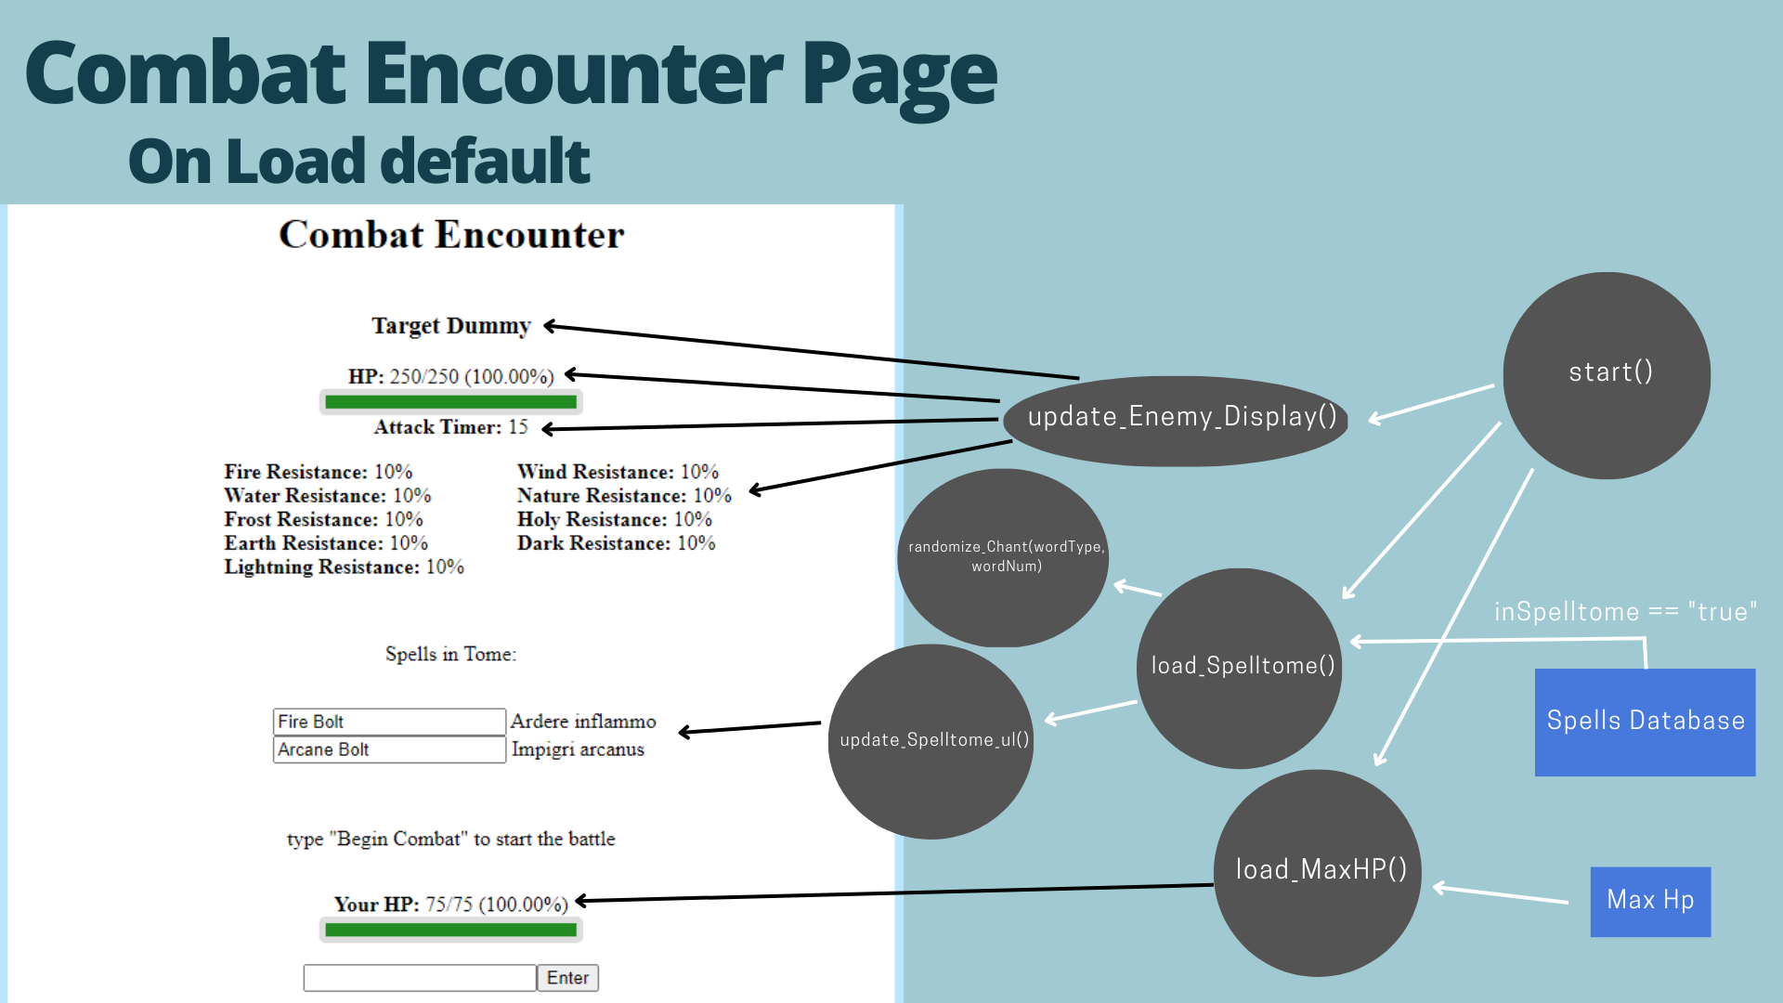

Figure 11

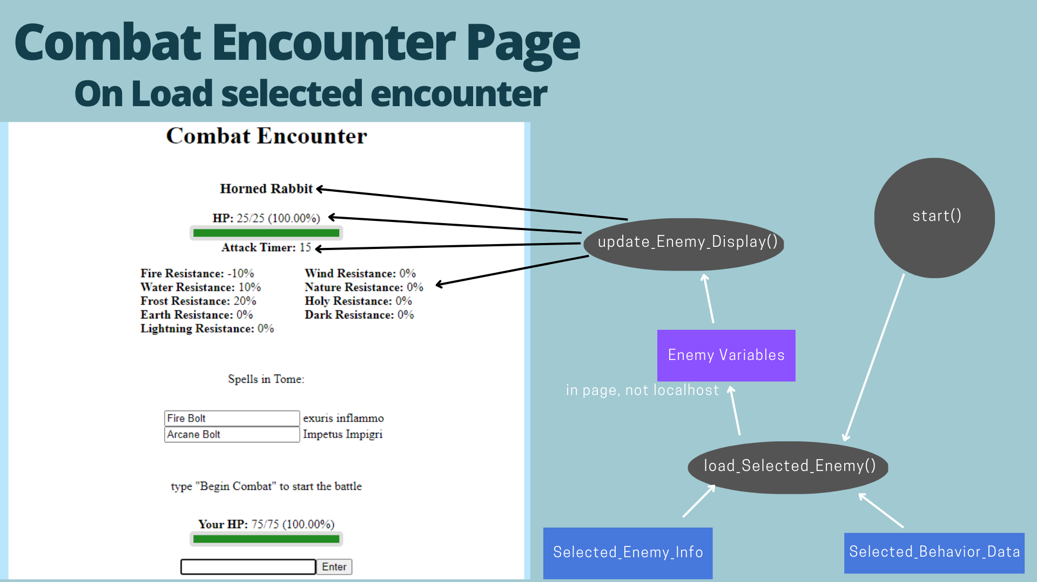

Figure 12

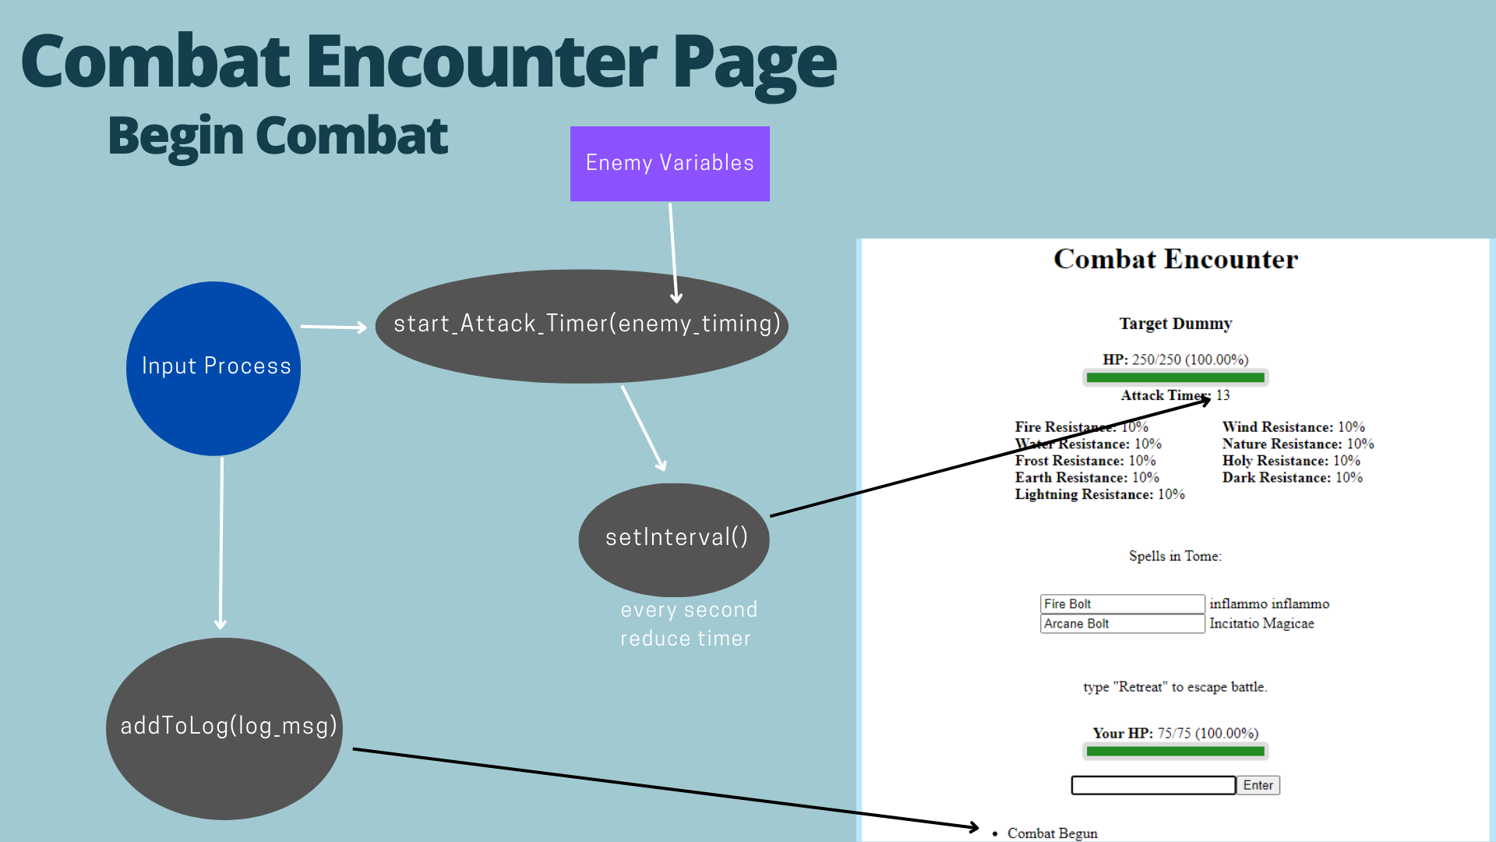

Figure 13

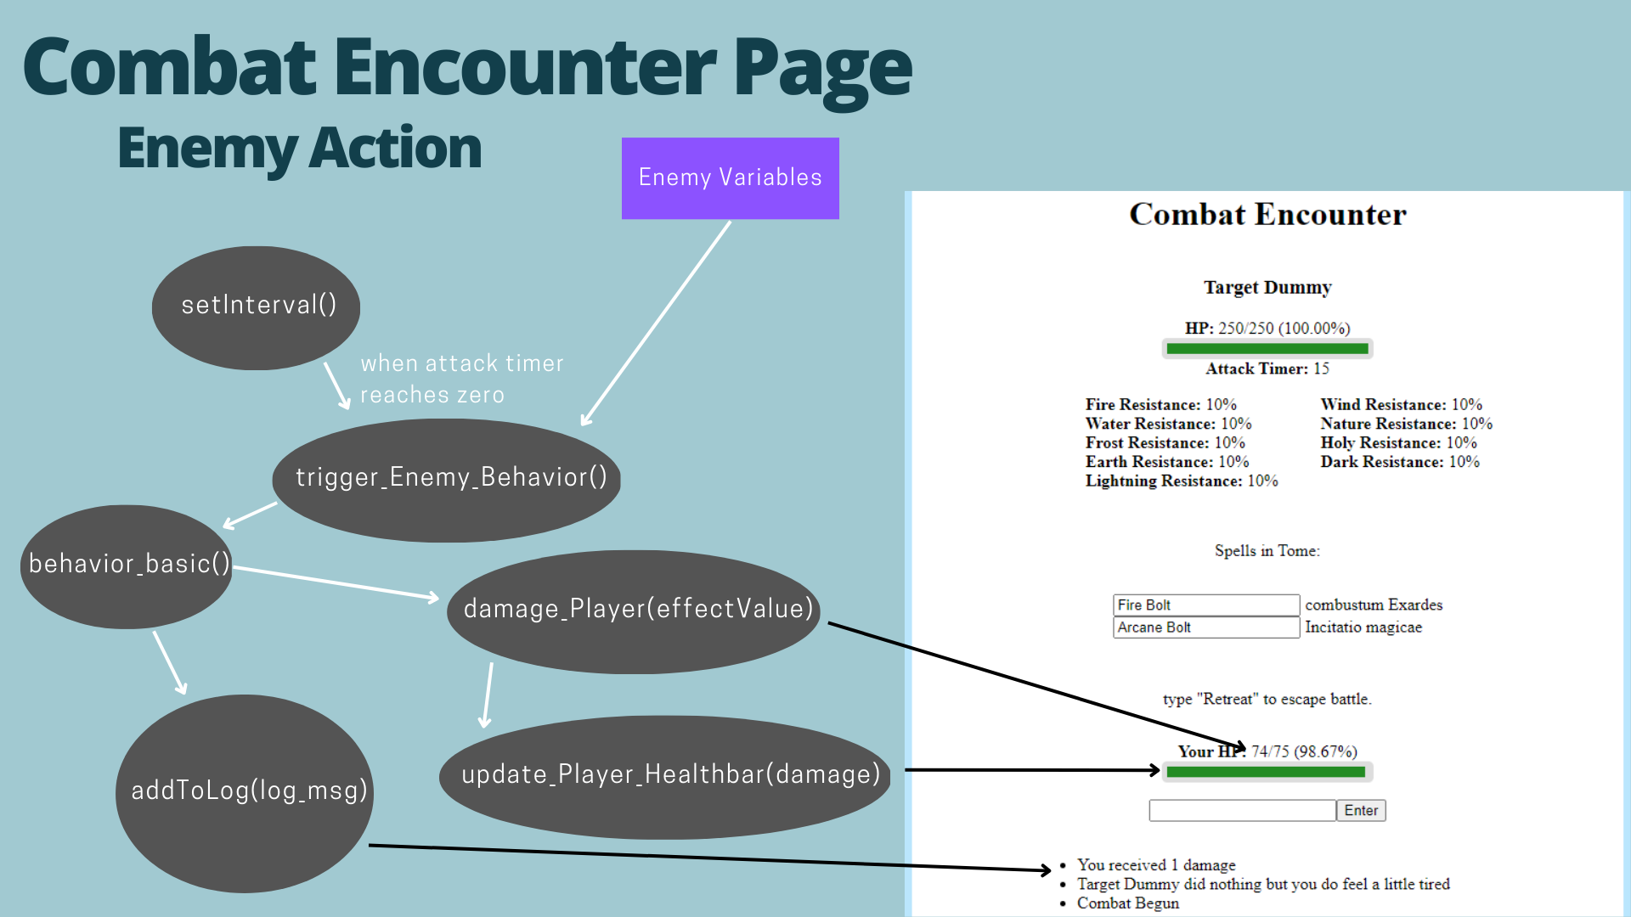

Figure 14

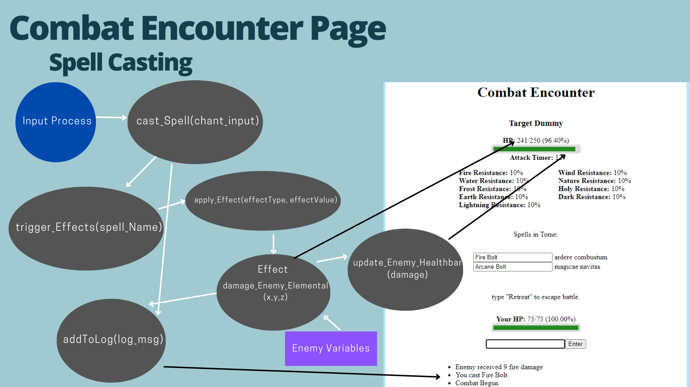

Figure 15

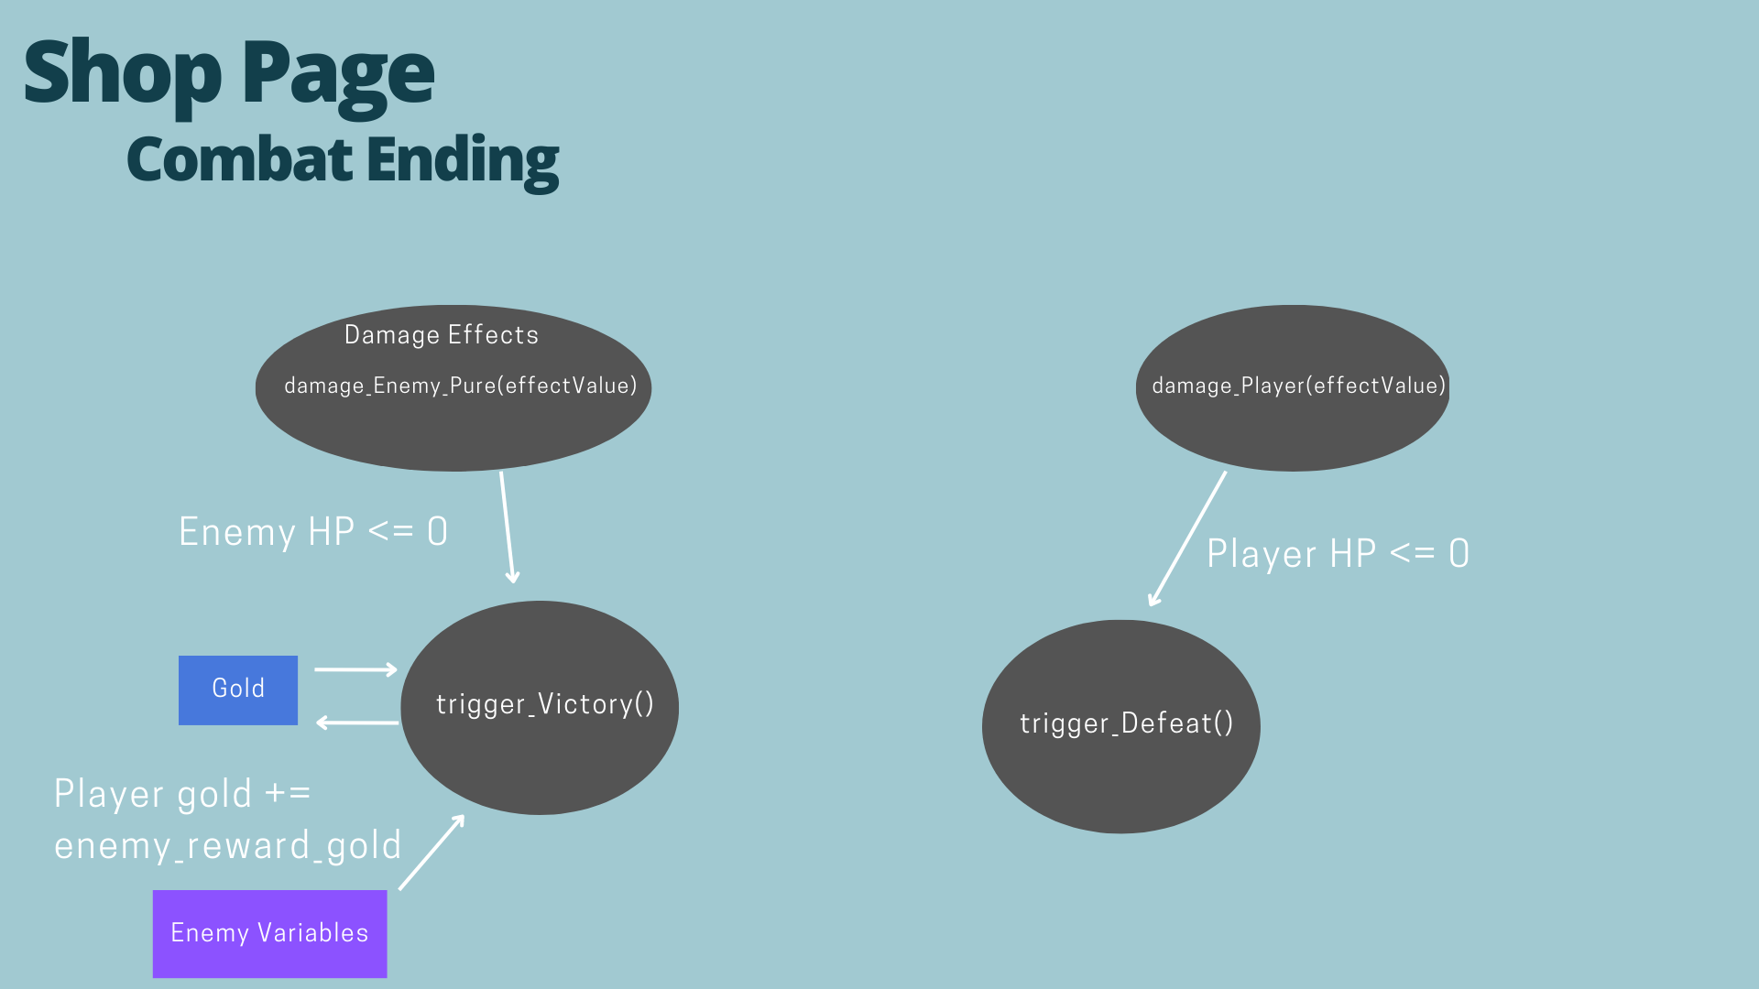

Figure 16

## Data Flow Diagram

Level-0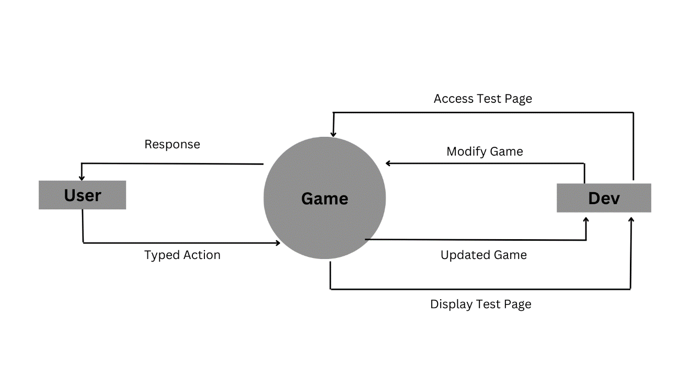

First Level

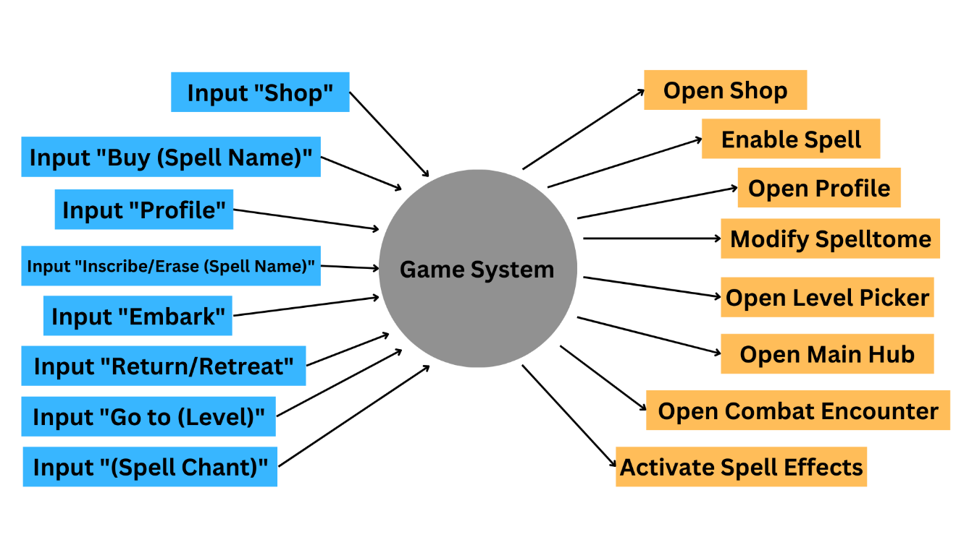

# Conclusion

## Conclusion

This will indeed be an entertaining typing game for the target players of the “gamer community” within the teenage to adult age bracket. Practicing typing is fun and progression is interesting.

## Recommendations

Using a server and database instead of local storage.

Using a proper game engine.

Adding a login and sign-up feature.

Adding social features.

Adding player vs player content.

Adding more levels.

Adding more spell and effects.

Adding player level, experience, and status points feature.

Locking spells under conditions like player level, status points, or cleared level

Adding equipment feature.

Having more developers.

REFERENCES

Use APA formatting for all references (in the body and in the listing here).

Widomski, D. (n.d.). Health Bar Code. Retrieved March 13, 2023, from https://codepen.io/dwidomski/pen/DegdPX

APPENDICES

##### <Appendix A:><Title>

Place your appendices here. Please be sure that these have been referenced in the body of document.